CSA1503-Cloud computing and big data analytics
Experiment-9
Name – Ramya S S
Regno – 192421226
Create a simple cloud software application for Hospital information system for SIMATS Hospital using any Cloud Service Provider to demonstrate SaaS with fields of patient name, age, address, phone, email, Attender name, attender phone, doctor name, diseases, etc.
INPUT
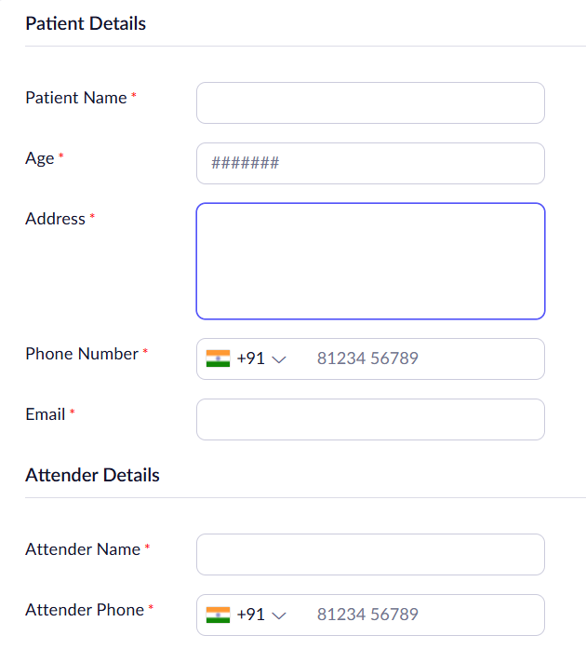
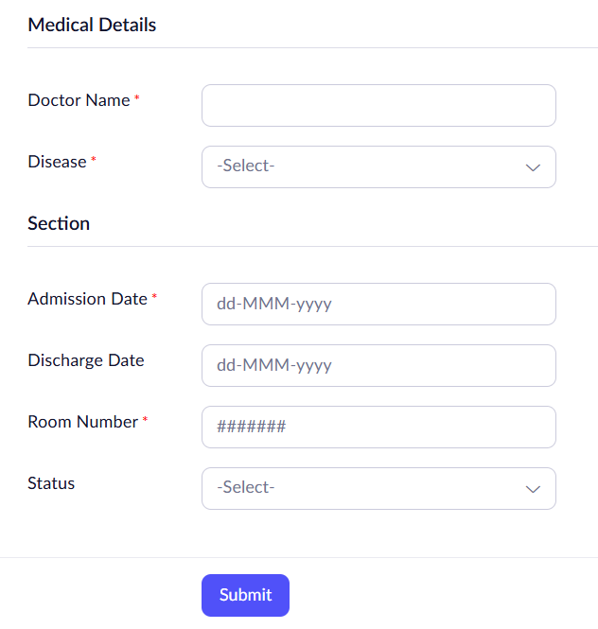
OUTPUT
